NAME: ___________________________

2019 Mathematics Specialist Investigation 2
Filling a Vase

Time Allowed: 50 minutes Total Marks: 33 Marks
A liquid flows into an irregular shaped vase at a constant rate. How does the height of the liquid change with time?
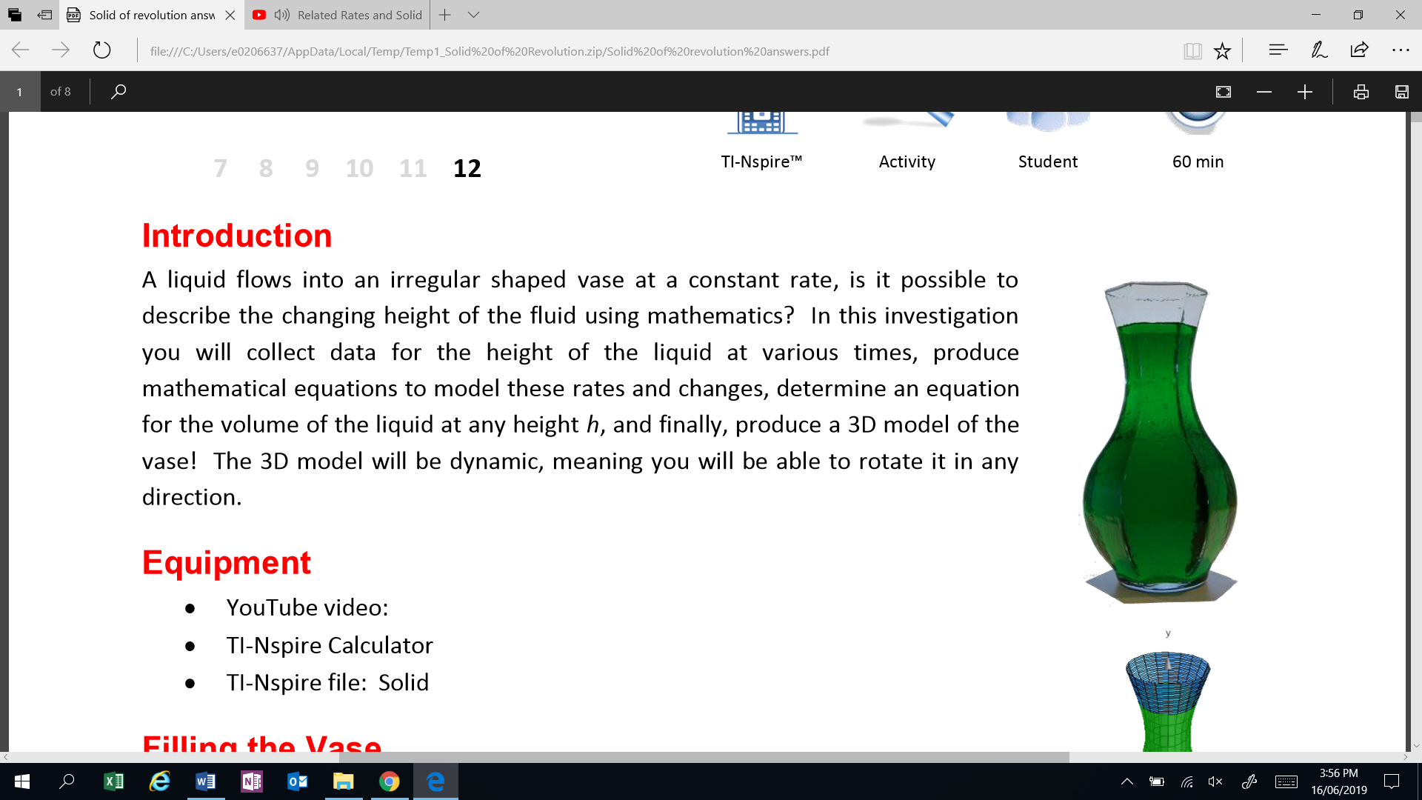
1. [7 marks]
The vase pictured is being filled at a constant rate to a depth of 20 cm (as shown), which takes 90 seconds. The table below shows the time taken in seconds to reach a given height in centimetres on the vase. Draw a graph of the height of the liquid compared to time. Relate key features of the graph to the shape of the vase.
t | 0 | 4 | 8 | 13 | 20 | 27 | 37 | 45 | 52 | 60 | 68 | 72 | 76 | 79 | 81 | 82 | 83 | 84.2 | 85.6 | 87.4 | 90
h | 0 | 1 | 2 | 3 | 4 | 5 | 6 | 7 | 8 | 9 | 10 | 11 | 12 | 13 | 14 | 15 | 16 | 17 | 18 | 19 | 20

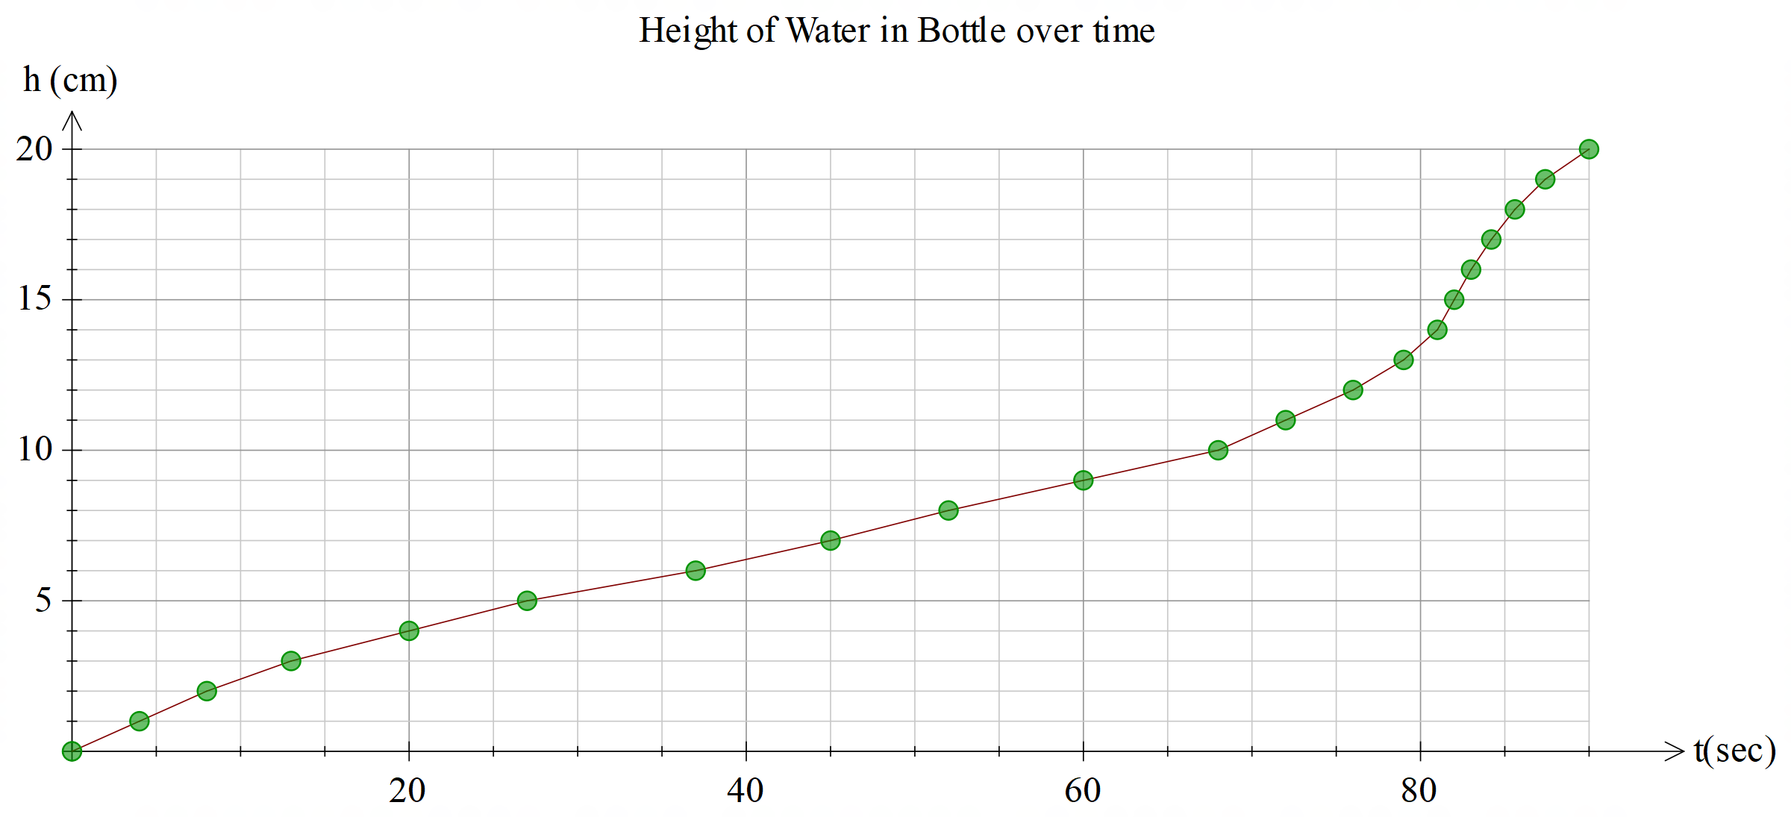
1 mark correct labelling
1 mark correct scale
2 marks correct points
1 mark join with smooth curve
1 mark state the gradient is steeper when the neck of the bottle is narrower
1 mark state the gradient is less steep when the graph is wider

3. [4 marks]
Choose an appropriate function to model the positive cross-section of the vase, given it is known the vase passes through points P, Q, R and S. Determine the equation for this function, coefficients should be accurate to 4 s.f.
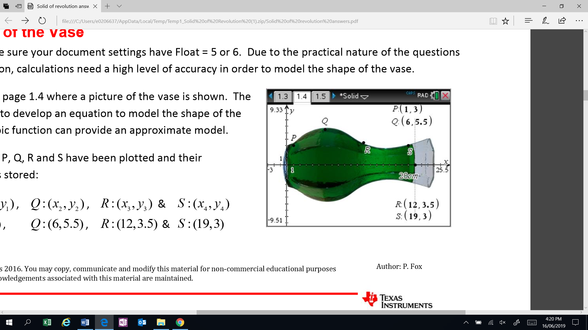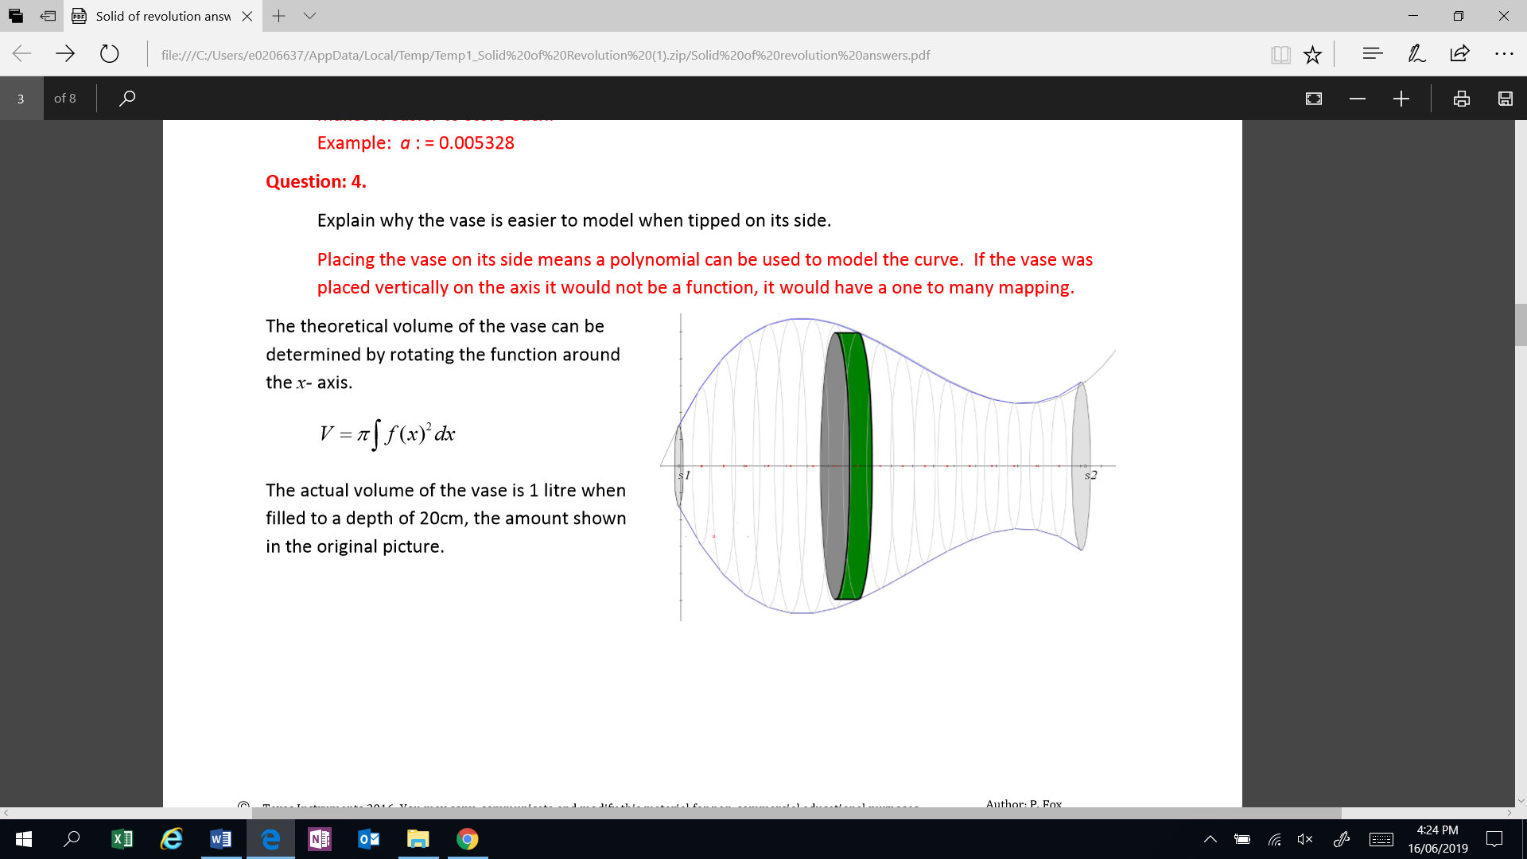

1 mark for stating a cubic
2 marks for equation:
$$y=0.005328h^{3}-0.1770h^{2}+1.510x+1.662$$

1 mark for using h

4. [3 marks]
The actual volume of the vase is 1 litre when filled to a depth of 20cm, the amount shown in the original picture. Prove that this is correct and explain why there may be a small amount of error in your solution.

1 mark $V=π\int_{0}^{20}{{\left(0.005328h^{3}-0.1770h^{2}+1.510x+1.662\right)}^{2}dh}$
1 mark $V=999.357 mL$
1 mark for any valid reason, such as rounding errors, error in reading measurements.

5. [13 marks]
Determine the rate of change of the height of the liquid, h, with respect to time, t, and hence determine where the rate of change of the height of the liquid, h, with respect to time, t is increasing at a maximum rate. Note: The rate can be in terms of the height of the liquid h. Discuss your solution in terms of the shape of the vase.
1 mark $\frac{dh}{dt}=\frac{dh}{dV}×\frac{dV}{dt}$

1 mark $\frac{dV}{dt}=\frac{1000}{90}=\frac{100}{9}{cm}^{3}s^{-1}$
3 marks $V=π\int{{\left(0.005328h^{3}-0.1770h^{2}+1.510x+1.662\right)}^{2}dh}$
$$V=1.274×{10}^{-5}h^{7}-9.875×{10}^{-4}h^{6}+0.02979h^{5}-0.4059h^{4}+1.772h^{3}+7.884h^{2}+8.678h+c$$
At h=0, V=0, therefore c=0.
$$V=1.274×{10}^{-5}h^{7}-9.875×{10}^{-4}h^{6}+0.02979h^{5}-0.4059h^{4}+1.772h^{3}+7.884h^{2}+8.678h$$

1 mark
$$\frac{dV}{dh}=8.918×{10}^{-4}h^{6}-5.925×{10}^{-3}h^{5}+0.1490h^{4}-1.624h^{3}+5.315h^{2}+15.77h+8.678$$

$$\frac{dh}{dt}=\frac{dh}{dV}×\frac{dV}{dt}$$
1 mark
$$\frac{dh}{dt}=\frac{1}{8.918×{10}^{-4}h^{6}-5.925×{10}^{-3}h^{5}+0.1490h^{4}-1.624h^{3}+5.315h^{2}+15.77h+8.678}×\frac{100}{9}$$

1 mark
$$\frac{d^{2}h}{dt^{2}}=\frac{100}{9\left(5.308×{10}^{-3}h^{5}-0.02963h^{4}+0.5960h^{3}-4.872h^{2}+10.63h+15.77\right)}$$

1 mark
$$\frac{d^{2}h}{dt^{2}}=0=\frac{100(5.351×{10}^{-4}h^{5}-0.02963h^{4}+0.5959h^{3}-4.871h^{2}+10.63h+15.77)}{9{\left(8.9189×{10}^{-5}h^{6}-5.925h^{5}+0.149h^{4}-1.624h^{3}+5.315h^{2}+15.77h+8.68\right)}^{2}}$$

1 mark $h=-0.98, h=5.767, h=16.45$
3 marks $h=-0.98$ cm is not valid as can’t have negative height, $h=5.767$ cm is when the bottle is the widest, so the rate of change of height with respect to time is a minimum, $h=16.45$ cm is when the bottle is the narrowest, so the rate of change of height with respect to time is a maximum.
6. [6 marks]
Determine a function relating the height of the liquid in the vase to time and define this rule as t(h). Discuss how well this function models the data.

$$\frac{dV}{dt}=\frac{1000}{90}=\frac{100}{9}{cm}^{3}s^{-1}$$
1 mark $V=\int{\frac{100}{9} dt}$
$V=$ $\frac{100}{9}t+c$ , at t=0, V= 0 $∴c=0$
1 mark $V=$ $\frac{100}{9}t$

$$V=1.274×{10}^{-5}h^{7}-9.875×{10}^{-4}h^{6}+0.02979h^{5}-0.4059h^{4}+1.772h^{3}+7.884h^{2}+8.678h$$

1 mark
$$\frac{100}{9}t=1.274×{10}^{-5}h^{7}-9.875×{10}^{-4}h^{6}+0.02979h^{5}-0.4059h^{4}+1.772h^{3}+7.884h^{2}+8.678h$$

1 mark
$t=\frac{9}{100}(1.274×{10}^{-5}h^{7}-9.875×{10}^{-4}h^{6}+0.02979h^{5}-0.4059h^{4}+1.772h^{3}+7.884h^{2}+8.678h$)

t | 0 | 4 | 8 | 13 | 20 | 27 | 37 | 45 | 52 | 60 | 68 | 72 | 76 | 79 | 81 | 82 | 83 | 84.2 | 85.6 | 87.4 | 90
t | 0 | 1.6 | 5.2 | 10.7 | 17.7 | 25.8 | 34.4 | 42.8 | 50.6 | 57.7 | 63.6 | 68.6 | 72.5 | 75.5 | 77.9 | 79.8 | 81.3 | 82.8 | 84.4 | 86.5 | 89.5
h | 0 | 1 | 2 | 3 | 4 | 5 | 6 | 7 | 8 | 9 | 10 | 11 | 12 | 13 | 14 | 15 | 16 | 17 | 18 | 19 | 20

2 marks
The data generated by the equation is fairly close to the raw data. Small deviations can be attributed to measurement errors, rounding and the approximation of the curve to the vase.

